|  |
| --- |
| Mass General Hospital |
| MGH Wayfinder |
| User Manual |
|  |
| **Group A** |
| **3/22/2012** |

|  |
| --- |
| This user manual has been developed to provide help to a user using the MGH Wayfinder application |

Table of Contents

**About MGH Wayfinder 2**

**Home 3**

Inputting Starting and Ending Locations 3

**Map 4**

**Directions 5**

**Directions List 6**

**Directory 7**

**About 8**

# About MGH Wayfinder

MGH Wayfinder gives you directions to and from points within the walk-in clinic in the Wang Ambulatory Care Center at Mass General Hospital. Choose or scan a barcode of your starting location. Choose your ending location. Use the generated map and list of directions to navigate to your location.

To use MGH Wayfinder, you need an Android mobile phone. To download the application for the first time, the phone must have either Wi-Fi or 3G/4G Internet connection.

# Home

The home page shows Mass General Hospitals logo and a brief description of what the application does.

To get directions follow the instructions for inputting starting and ending locations listed below and click “get.”

You can also access other pages in the application at the bottom of the home page.

### Inputting Starting and Ending Locations

Starting location can either be chosen from an intuitive selection menu or scanned via QR Code at the hospital. Ending location can be chosen from drop down lists.

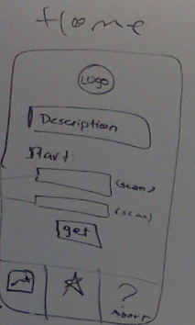

View About Page

View Map

Select Ending Location

Select Starting Location

Scan QR Code

View Doctor Directory

|  |  |
| --- | --- |
| Select Starting Location | Tap the drop down menus next to starting location? |
| Scan QR Code | Tap the scan QR Code button? |
| Select Ending Location | Tap the drop down menus next to ending location? |
| View Map | Brings you to a view of the maps. No path will be drawn if you choose this first. |
| View Doctor Directory | Brings you to a page that lists doctors that are part of the walk-in clinic. |
| View About Page | Brings you to a page that will aid you in using the application. |

# Map

The map page is a floor plan view of the two floors. You can view the map without selecting starting and endings locations.

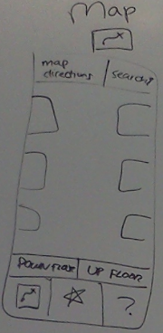

Up Floor

Down Floor

Map Directions

Search

|  |  |
| --- | --- |
| Search | Search for a specific room or a point of interest. |
| Map Directions | Go back to the home page to select starting and ending locations |
| Down Floor | Selects the map of the floor below the floor you are currently viewing |
| Up Floor | Selects the map of the floor above the floor you are currently viewing |

# Directions

After selecting a starting and ending location, the map is brought up. A path is drawn on the map from the starting location to the ending location.

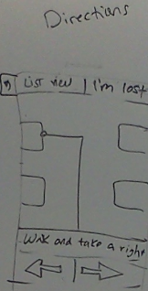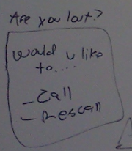

List View

Back

|  |  |
| --- | --- |
| Back | Go back to the home page. |
| List View | View the directions as a list. |
| I’m Lost | Pull up a prompt to either re-input your current location or call a hospital help desk. |

# Directions List

After viewing the directions on a map it is possible to view the directions as a text list.

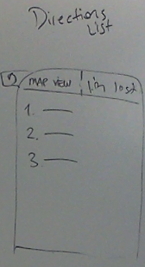

I’m Lost

Map View

Back

|  |  |
| --- | --- |
| Back | Go back to the home page. |
| Map View | View the directions on the map. |
| I’m Lost | Pull up a prompt to either re-input your current location or call a hospital help desk. |

# Directory

The directory lists doctors that work in the walk-in clinic and information that is relevant to patients.

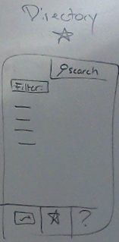

Filter

Search

|  |  |
| --- | --- |
| Search | Search for a doctor |
| Filter | Filter doctors based on certain criteria |

# About

You can view information about the application that will help in using it when you don’t have your user manual handy. The about page lists frequently asked questions. It also allows users to search for specific keywords.

